Governor Profile template

Name and picture | Beth Miller  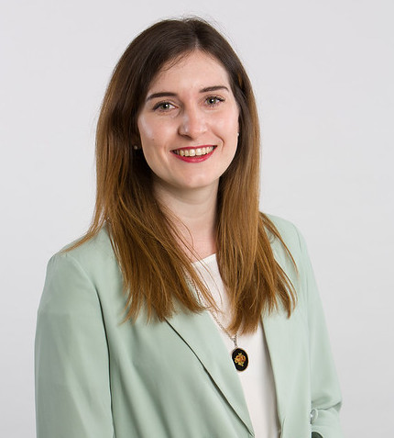
Role on the Governing Body | Governor (2020 – present)
Background and reason why you are a Governor | I grew up and went to school in Corby and now live locally with my partner and our very spoilt dog, Ozzy. I currently work at the UK’s development finance institution where we invest in businesses in developing countries to create jobs and generate economic growth to alleviate poverty.  While I didn’t attend Our Lady’s, the school and church have always been important to my family. Education is also a big passion of mine. A good education can have a transformational impact on a child’s life chances, and I am keen do my bit to support today’s young people reach their full potential.

