Governor Profile template

Name and picture | Claire Wright  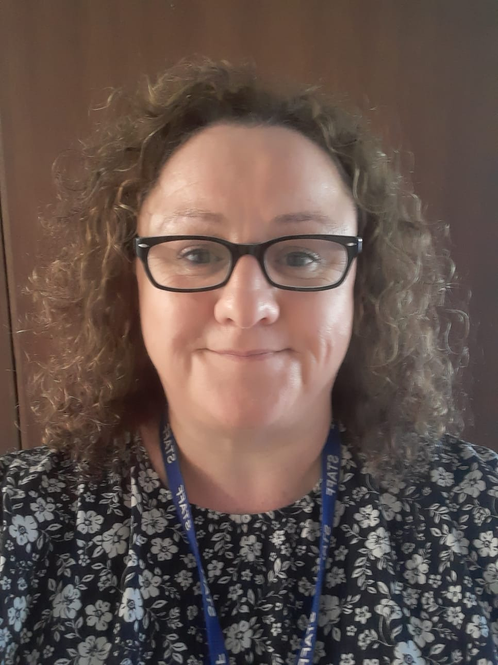
Role on the Governing Body | Safeguarding Governor  The Safeguarding governor role involves understanding the safeguarding requirements of the school and governing board. Supporting the work of the Designated Safeguarding Lead also to Report back to the Governing Body about how effective safeguarding is. Check that the school is compliant with statutory guidance. Check out whether there is a consistency in safeguarding across the whole school. Make sure that there are effective systems in place to keep children safe.
Background and reason why you are a Governor | I have lived in Corby most of my life and come from a large catholic family. I attended Our Lady’s School many years ago, back then Corby had a huge Catholic Community and a Catholic Secondary School. This helped merge the Catholic communities as we travelled from all over Corby and surrounding villages to continue our Catholic education.  I am a mother of 3 children who all attended Our Lady’s School and have all since left. I have always felt a strong connection with Our Lady’s School, and this also led to me seeking employment in the school. I was lucky in securing employment in the school and enjoyed some happy years working with many of the current staff.  I feel the experience I have of being a pupil, a parent and a staff member have given me a deep respect for the school, and I understand how dedicated everyone who works there is to the wellbeing and education of the fantastic pupils and families. This helped with my decision to join the governors board to maintain my links with the school and help support the school and its families.  I did leave the school and currently work for a charity that specializes in Therapeutic Counselling and Wellbeing support services for children and young people across Northamptonshire and Leicestershire. When I worked at Our Lady’s I was a Designated Safeguarding Lead and have continued to develop those skills in my existing role.  I look forward to supporting our brilliant school community in the safeguarding governor role.

