Name | Donna Gallagher  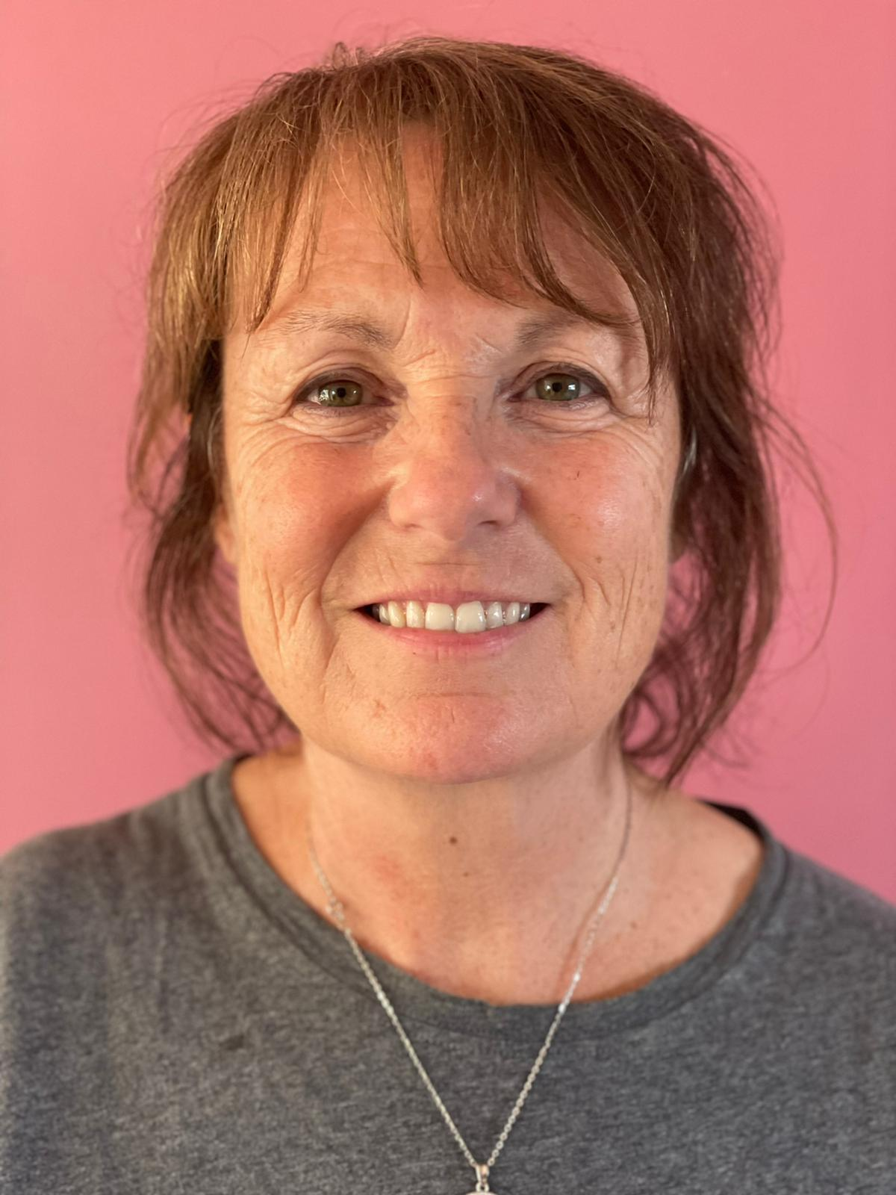
Role on the Governing Body | I have been Chair of Governors at the school since Sept 2018  I have also been a foundation governor with the lead for safeguarding for 3 years  I regularly meet with other Governors, Headteacher and Staff.  to make sure all pupils’ needs are being met by the school
Background and reason why you are a Governor | I am from Corby and attended our Lady of Washingham school!  It is a great privilege to be involved now as a Governor.  I have lived and worked around Corby most of life in services for Families and Children in Northants, Rutland and Leicestershire. ,I have managed services in Safeguarding, children with disabilities, fostering and adoption and mental health.  I have also been a therapeutic foster parent for children with specific behavioral issues when I worked in USA  I have recently retired from my role as Deputy Head of Centre for Family Support at Pen Green children and families Centre in Corby  I am very impressed by the strong Catholic ethos that the school embodies, the outstanding care shown to the children and families and the school’s commitment to consistently high standards of education.  I am useing my work place skills to supports the Headteacher, staff and pupils of the school

A

