Governor Profile template

Name and picture | 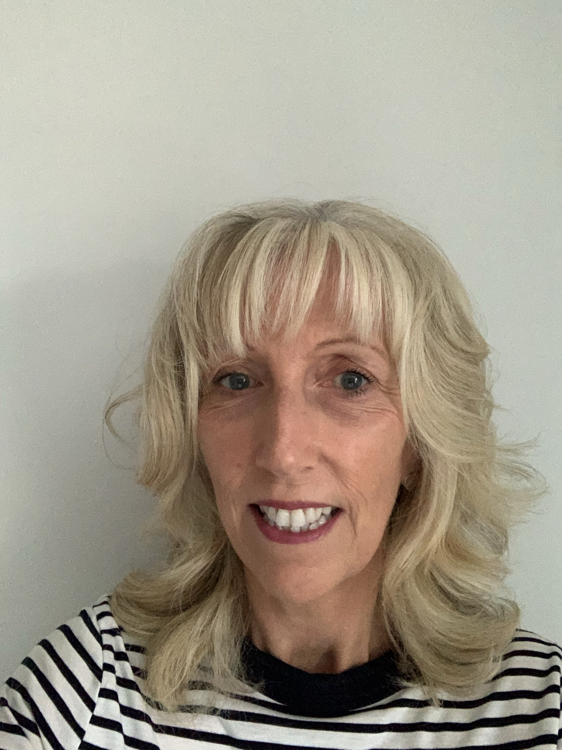  Joanne Walsh
Role on the Governing Body | I have been a foundation governor at Our Lady’s for 6 months.  I am the lead governor for LAC and SEND.  As governors we meet regularly to ensure the effective running of the school and the wellbeing of the children and staff.
Background and reason why you are a Governor | I attended Our Lady’s infant and junior school and my children are now at the school. My family and I regularly attend Our Lady’s Church.  I have worked as a nurse for thirty years, the last twenty years at Kettering General Hospital.  I have always lived in Corby and local to the school. I understand the close knit community we have and the importance of faith and family values.  This awareness and the skills from my role as a nurse assist me in the role of a governor.  It’s vital our children receive the education and support to make the best start to life as possible. It’s a privilege to be able to support the staff in providing this to our children.

