

Our Lady of Walsingham Catholic Primary School


Adopted by Governors: Autumn 2025

Date for renewal: Autumn 2026

Behaviour Policy

Our Lady of Walsingham Catholic Primary School is a learning community based on Gospel values. We aim to develop our pupils by encouraging their growth as spiritual and moral individuals who have the confidence to make the best choices. We encourage them to aspire to achieve and to realise their full potential. We nurture our pupils as they grow into responsible members of our community and to develop a lifelong love of learning.

Hand in hand with God, we love, live and learn.

Vision
At Our Lady of Walsingham Catholic Primary School, we strive to create a welcoming, safe and nurturing environment, where every pupil feels valued, respected and empowered. We aim for all members of our school community to model positive behaviour, kindness, responsibility, resilience and fairness to encourage thoughtful and responsible choices. Fostering a culture of high and consistent expectations and mutual respect, we aim to create an effective learning culture that promotes personal and academic growth, self-esteem and confidence. By working together, and inspired by Gospel Values, we can encourage pupils to grow into responsible and compassionate citizens who contribute positively to their community.

Introduction

This behaviour policy has been written after consultation with governors, staff, pupils and parents. The aims of this policy are:

- To provide clear guidance to all staff, pupils and parents as to the expectations that our school has in relation to the behaviour of our pupils.
- To ensure high expectations for behaviour and conduct,
- To promote the schools’ aims and values.
- To encourage all pupils to assume individual responsibility for their behaviour during and outside of school hours as well as on and off school premises.
- To ensure a consistent, fair approach in managing behaviour.
- To support staff with their rights to screen and search as well as the use of reasonable force if and when necessary.
- To develop a positive and safe learning environment in which bullying will not be tolerated

Ready, Respectful, Safe
At Our Lady’s, we are committed to creating an environment where exemplary behaviour is at the heart of effective learning. Everyone is expected to maintain the highest standards of personal conduct, to accept responsibility for their behaviour and encourage others to do the same.

We encourage our learners to be ambitious for themselves and for others, as we challenge and support them in questioning the world and in finding solutions.

We want our learners to be ready to learn, to be respectful of each other and to feel safe.

All staff, pupils, governors and parents recognise that we have the right to learn in an orderly community to ensure effective learning can take place. As part of our commitment to this right, we have ensured our three key school rules -ready, respectful and safe- are clear and simplified to enable all our pupils to understand and adhere to them, whether their age or developmental stage

We strive to ensure that all members of our school community know and understand what these words mean, how they can use these words to help them ‘anchor’ their behaviour choices and what it may look like when they are ready, respectful and safe.

We are READY to learn. This means:
- We arrive at school on time and with our equipment
- We come to school to learn and fulfil our potential
- We show that we are listening and try our best.

We are RESPECTFUL. This means:
- We treat others how we would like to be treated
- We listen when others speak
- We take care of our school environment and all of its possessions
- We welcome and celebrate what makes us different

We are SAFE. This means:
- We are responsible for our behaviour
- We move around school in a safe and calm manner
- We follow instructions to keep ourselves and other safe
- We use equipment safely and we stay safe online.

Roles and Rresponsibilities
Staff are responsible for:
- Implementing the behaviour policy consistently
- Modelling positive behaviour
- Creating a supportive, safe, caring and nurturing environment
- Providing reasonable adjustments and adaptations for social emotional and behavioural needs of identified pupils
- Communicating and sharing information about incidents and concerns with parents via a phone call, class dojo or a meeting in school
- Ensuring that pupils, support staff and themselves are and feel safe
- The senior leadership team will support staff in responding to serious behaviour incidents and where applicable, support staff to implement effective behaviour management strategies to foster a safe, secure and effective learning environment

The senior leadership team will support colleagues in the implementation of this policy and have strategic oversight for the behaviour ethos and culture of the school.
Responsibility for behaviour belongs to all staff.

All staff: teaching (including supply), support, office and volunteers have responsibility for ensuring policy and procedures are followed and applied consistently by all pupils (not just those within their class). Annual behaviour management training updates are given to all staff. This policy is also part of the staff Induction pack for all new/temporary staff.

All staff should be aware of and maintain an appropriate degree of influence, control and authority at all times. All staff have a duty to notice and acknowledge positive behaviours and to intervene, address and support pupils demonstrating unwanted behaviour. Honest supportive and ongoing communication between school and parents is an integral part of the role, especially for class teacher.

Pupils are responsible for their actions and their voice is listened to and valued. In the rare incidents of bullying or aggression, these must always be immediately reported to an adult.

Parents who have chosen to send their pupil to Our Lady’s have agreed to support this policy and to make sure that they are developing, promoting and expecting positive behaviour. Parents have a key responsibility for encouraging high standards and this can be achieved by working in partnership with the school.

In conjunction with these responsibilities, the school sets out our beliefs and expectations of all members of our school community in our Home School Agreement (Appendix One)

Supporting pupils, staff and parents

We have very high standards of pastoral care in our school and strive to provide appropriate and personalised guidance and support. Staff, pupils and their parents are encouraged to share concerns that they have with members of the school Inclusion Team or senior leadership team so that appropriate actions of support can be discussed, agreed, implemented and their impact reviewed.

Promoting Positive Behaviour and Play

At all times, our staff are encouraged to adopt positive behaviour strategies to support our pupils to aspire to behave as well as they possibly can.

Create a supportive environment
- Establish clear, age-appropriate expectations and routines
- Set up the physical space in the classroom to encourage positive behaviours for learning, social interactions and a purposeful learning environment
- Encourage and promote a safe and secure ethos through high expectations, clear instructions, consistency, fairness and where mistakes are framed as a learning opportunity
- Staff develop positive relationships and get to know their pupils, they know how well they respond to thumbs up, stickers, smiles or positive body language and dojo points.
- Give whole-class, groups and individual pupils positive attention and time.

Positive reinforcement
- Acknowledge positive behaviour both explicitly and discreetly to help pupils learn acceptable behaviours using stickers, dojo points, class rewards, specific responsibilities or privileges.
- Staff should be sensitive to individual pupils and how they respond to praise. When giving praise, staff should be specific and descriptive such as ‘I like the way you worked with and listened to your partner to solve that problem’ or ‘well done for using you words to explain how you were feeling’. Staff should avoid generic praise
- Sending pupils to visit a teacher in another class or a member of the senior leadership team
- Sharing achievements and successes with parents face-to-face, via telephone or Class Dojo messaging
- Weekly VIP celebration assembly and termly Ambassador Assembly
- PSHE and RE Curriculum
- Whole-school Assemblies
Respond effectively to challenging behaviour
- Remain calm and be aware of and control feelings and emotions when addressing persistent negative behaviours or challenging situations. This encourages individuals to ‘mirror’ what they see
- Be aware of volume, body language, facial expression, proximity
- Maintain a respectful and positive tone
- Actively listen and give pupils time to express their views, feelings and
- Simplify language, avoid long or rhetorical questions or narrations of negative behaviour
- Scan the classroom/hall/playground/area regularly and use proximity, presence and body language to influence behaviour choices and desired behaviours
- Use positive language to redirect and emphasize desired behaviours
- Anchor all behaviour expectations, reflections and discussions to Ready, Respectful, Safe
- Avoid unnecessary confrontation
- Be assertive, avoid venting, high pitch or exasperated tones
- In most instances, when addressing unwanted or negative behaviour, this should be carried our discreetly
- Avoid addressing negative behaviour from across the classroom or in front of large groups of pupils or adults as this can cause shame and embarrassment
- Avoid ‘blanket’ whole-class consequences unless there is evidence that each individual child has not followed the school behaviour expectations as this is unfair and undermines motivation to maintain positive behaviour
- Provide pupils with clear and limited choices such as “Daisy, you can either work quietly by yourself or you can come up and sit with me
Teach and model social-emotional skills
- Help pupils to identify and express their emotions safely and appropriately. The prompts ‘’use your words to explain what the problem is” or “can you write/draw what happened and how it made you feel”
- Acknowledge, label and discuss feelings openly. This can pre-empt pupils resorting to negative ways to get attention
- Listen to pupils, make them feel like they belong and are valued
- Keep an open mind and be aware of conscious/unconscious biases
- Aim to ‘connect before correct’
Consistency and making standards ‘standard’
- For pupils to thrive and learn in school, they require staff to act consistently, fairly and reliably. When pupils can predict what will happen (cause and effect) they will feel calm, safe and secure. This in turn will promote expected behaviours.

With particular regard to bullying our proactive strategies include:

- We are a listening and telling school. This is the message that will be promoted at all times and with all audiences. There is an agreed collective responsibility to address any incidents of bullying observed.
- The issue of bullying will be raised regularly in order to maintain awareness of the issue through school assemblies and prominent pictorial displays and posters.
- Every opportunity to promote whole school initiatives such as anti-bullying week, theatre productions and external speakers will be taken.
- The School Council will include bullying as an agenda item regularly. Peer support systems for students will be promoted and training provided for both staff and students.
- Parents are actively encouraged to discuss any worries or concerns with their pupil’s class teacher who will pass the relevant information onto the head teacher if necessary. Any complaints will be dealt with immediately by the school and noted.
- Our lunchtime supervisors are proactive in preventing bullying and are aware of the ways in which they should deal with any situations should they arise.
- The Governing Body and SLT will monitor bullying via staff meetings, auditing complaints from pupils and parents.
- Staff will use the information recorded about bullying to inform their teaching. Issues surrounding bullying will be addressed within the PSHE and RE curriculums. It may also be addressed throughout other curriculum areas such as dance, drama, story etc.
- Our responses to different types of bullying may vary from time to time, depending on the type of bullying, where it occurs (i.e. at home via cyberbullying) and the level of severity.
- Where parents report incidents of bullying that have occurred outside of school hours but involve other students in the school, the staff will support the parents as and when they can to come to a positive outcome for all involved.

Classroom behaviour management system

The school uses a traffic light system to support behaviour management. This is intended to promote a consistent culture of high expectations and believe and invest in pupils’ capacity and agency to modify their behaviour. There are three sessions to the day – morning until break, from break until lunch and from lunch until home time. The procedure runs as follows:

- A verbal reminder to the pupil that continuing with unacceptable behaviour will lead to their name being moved from the green to the range traffic light
- Name moved to the orange traffic light.
- Reminder that if the behaviour continues, they will be moved to the Red traffic light and this will result in losing 5 minutes of break or lunch time to reflect on their behaviour and complete a Behaviour Reflection Sheet. This time must not be earned back by a pupil for subsequent ‘good’ behaviour. To ensure that this sanction has maximum effect it is crucial for the pupil to spend this 5 minutes in the class and with the adult who enforced the sanction (in most cases this will be the class or covering teacher). This will also support the whole-school expectation that all adults working at the school are responsible for behaviour.
- If the behaviour continues then the pupil will move to the blue light which will lead to them being required to exit the class for a fixed period of time to complete a ‘remove, reset, reflect’ cycle with a member of the Inclusion Team or Senior Member of staff and an adult from the classroom if appropriate/possible.

‘Low-level’ behaviour which goes against the ready, respectful safe code of conduct leading to a pupil being on the red traffic light will be recorded on the Bromcom Behaviour Module as Tier 1 (see Appendix 6) behaviour by class teachers. Parent notification of a pupil moving to red is at the teacher’s discretion. Class teachers will inform a parent if their child has moved to blue and completed a remove, reset, reflect’ cycle. Children will take home their written reflection if they have been required to complete one.

Serious or persistent negative behaviours and/or those which lead to the pupil being on the blue traffic light will be recorded on Bromcom Behaviour Module as a Tier 2/3 (see Appendix 6) by a teachers, member of the Inclusion team or senior member of staff.

Serious or persistent unacceptable behaviour may result in teachers completing an ‘Orange Behaviour Incident Form’. Such incidents will be reviewed regularly by the head teacher and SLT and appropriate actions of support and monitoring will be agreed.

All behaviour incidents must be recorded on Bromcom by the end of the school week. This will enable the SLT to analyse behaviour trends on a weekly basis and target support measures for children and staff in a timely and consistent manner.

There may be times when persistent Tier 1 or more serious Tier 2/3 incidents require a more severe consequence. These consequences will be administered fairly after:
- A review of the incident/s has taken place.
- The pupils involved have been given the chance to express their account of the incident/s.
- Witnesses (where appropriate) have been spoken to.

If it is deemed necessary/appropriate, a member of the school’s safeguarding team may report the behaviour incident to the Police or Multi-Agency-Safeguarding-Hub via telephone and/or online referral. The incident may also be recorded on the school safeguarding recording system, MyConcern.

Consequences for persistent Tier 1 or a Tier 2/3 incident include but are not limited to:
- Partial or whole removal of lunchtime or break and written and/or verbal reflection completed and unfinished work is completed
- Temporary removal from the playground at lunchtime and break to complete reflection and other work to support a pupil to modify their behaviour
- Suspension from school for a fixed period of day/s or lunchtime
- Direction to access the school’s indoor playtime provision for a fixed period of time
- Temporary removal of access to breakfast and after school clubs
- Temporary removal of access to external school sports events
- Temporary removal of access to external visits and trips
- Holding and adult’s hand during lunchtime and break (For pupils in Foundation Stage and KS1)

Break time lining up routine:
- At 11:07 all class teachers (or person covering the class) will make their way to the playground and stand where their class line up.
- The bell will ring at 11:09 to signal the end of playtime.
- All teachers or the primary adult supervising the class should be on the playground by 11:10
- All children are expected, reminded and redirected to stop their play and interactions (with a ‘stop’ hand signal and verbally if required)
- An adult on duty will then blow the whistle to signal that the children must walk to their lining up area.
- It is important that every day all adults promote, model and where necessary, redirect children to transition to their line in a calm, safe and prompt manner.
- All children should be led off the playground by an adult by 11:12 at the latest.

Lunchtime lining up routine:
- A bell will ring indicating that all children should stop their play
- A second bell will be rung to indicate all children moving to their class lines
- Lunchtime adults to supervise the lining up of their classes and bring the children into eat their lunch in a calm and orderly fashion.

Lunchtime behaviour management strategies and consequences:
- Adults will actively engage with pupils’ play
- Use of specific praise for noticing sensible, safe, helpful, kind behaviour in the dining hall and whilst playing outside is encouraged
- Ensure pupils use play equipment safely and purposefully
- Lunchtime Supervisors communicate effectively with class teachers to ensure concerns are fed back at the end of lunchtime.
- Reminders about positive play
- Holding an adult’s hand (For pupils in the Foundations Stage and KS1) or walking with an adult on duty
- Consideration given to removal of next lunchtime or break

The school has the power to impose reasonable sanctions for non-criminal misbehaviour that has occurred outside of the school premises and is witnessed by a member of staff or reported to the school. This may include incidences of cyber bullying.

The action taken by the school on these occasions will be decided on a case-by-case basis by the head teacher, depending upon the severity of the behaviour. The consequences imposed are very likely to be similar to those listed above. In all cases, parents will be informed of the situation and the actions taken.

Suspension and/or Exclusion

The decision to suspend a pupil is never taken lightly and this course of action will only be taken because of severe behaviour or as a result of continuous disruptive behaviour. Such behaviour may include:

- Physical aggression against another pupil
- Physical aggression against an adult
- Verbal abuse or threatening behaviour towards another pupil or adult
- Bullying
- Prejudicial behaviour
- Racist abuse or homophobic abuse
- Sexualised behaviour
- Damage to school or personal property
- Theft
- Persistent disruptive behaviour in the classroom or on the playground and/or persistent refusal to follow instructions

Decisions on suspension or permanent exclusions will be based on the guidance set out in the school Suspension and Exclusion Policy

To support our pupils over lunchtime, it may be necessary for parents to make alternative arrangements for a short-term period.

Following a suspension, the pupil and their parent/carer will meet with a member of the senior leadership team to discuss reintegration and expectations going forward. It should be made clear what changes in behaviour are required to avoid future consequences.

If there are repeated fixed-term suspensions or if a pupil is guilty of extremely serious misconduct, then the head teacher or their representative could impose a permanent exclusion.

Trips or visits outside the school building
Whilst our school acknowledges all pupils have a right to a broad and balanced curriculum, at times it may be necessary to stop a pupil from going on a trip or event in or outside of school for safety reasons or to be accompanied by their parent/carer.

These behaviours and consequences are sufficiently serious to warrant withdrawal from a school trip, including sporting events:

- School suspensions for violence/aggression - both physical and verbal
- Pupils who are on part-time timetables due to their behaviour in school
- Pupils who have been restrained or removed from class due to their behaviour
- Pupils who are flight risks – those who have run away from school
- Consistently refusing adult direction and instructions

Pupils and parents should be aware of these guidelines. The head teacher has ultimate discretion in these matters and will always make a decision that is clear fair and transparent and ensures the safety of all those involved.

Use of reasonable force

Occasionally, it is necessary to use physical intervention if a pupil is posing a risk to themselves or others. This will always be a last resort when all other de-escalating strategies have been exhausted.

The school follows the principles outlined by the Use of Reasonable Force document published by the DfE.

All members of school staff have a legal power to use reasonable force.

This power applies to any member of staff at the school. It can also apply to people whom the head teacher has temporarily put in charge of pupils such as unpaid volunteers or parents accompanying students on a school organised visit.

Reasonable force can be used to prevent pupils from hurting themselves or others, from damaging property, or from causing disorder. In a school, force is used for two main purposes – to control pupils or to restrain them.

The decision on whether or not to physically intervene is down to the professional judgement of the staff member concerned and should always depend on the individual circumstances.

Schools can use reasonable force to:
- Remove disruptive pupils from the classroom where they have refused to follow an instruction to do so
- Prevent a pupil behaving in a way that disrupts a school event or a school trip or visit
- Prevent a pupil leaving the classroom where allowing the pupil to leave would risk their safety or lead to behaviour that disrupts the behaviour of others
- Prevent a pupil from attacking a member of staff or another pupil, or to stop a fight in the playground; and
- Restrain a pupil at risk of harming themselves through physical outbursts.

Schools cannot:
- Use force as a punishment – it is always unlawful to use force as a punishment.’

Training
Our Lady of Walsingham Catholic Primary School aims to ensure that all relevant staff receive the necessary training so that they are able to act safely when a pupil needs to be restrained. They are also taught the techniques and strategies to support de- escalation and to carefully assess the need for restraint or reasonable force.

There is an additional Restraint Policy for staff to follow should this be necessary.

Power to search without consent

In addition to the general power to use reasonable force described above, the head teacher and authorised staff can use such force as is reasonable to conduct a search of a pupil or their possessions if they suspect that a pupil is in possession of the following “prohibited items”:
- knives and weapons
- alcohol
- illegal drugs
- stolen items
- tobacco and cigarette papers
- e-cigarettes
- fireworks
- pornographic images
- any article that has been or is likely to be used to commit an offence, cause personal injury or damage to property
In addition, the below items are also able to be searched for:
- stolen property
Before any search takes place, the member of staff conducting the search should explain to the pupil why they are being searched, how and where the search is going to take place and give them the opportunity to ask any questions.
The authorised member of staff should always seek the co-operation of the pupil before conducting a search. If the pupil is not willing to co-operate with the search, the member of staff should consider why this is. Reasons might include that they:
- are in possession of a prohibited item;
- do not understand the instruction;
- are unaware of what a search may involve; or
- have had a previous distressing experience of being searched.
If the pupil still refuses to co-operate, the member of staff should assess whether it is appropriate to use reasonable force to conduct the search. A member of staff can use such force as is reasonable to search for any prohibited item, but not to search for items which are identified only in the school rules. The decision to use reasonable force should be made on a case-by-case basis. The member of staff should consider whether conducting the search will prevent the pupil harming themselves or others, damaging property or from causing disorder.

At-a-glance procedure for the decision to carry out a search without consent is as follows:
- Concern raised regarding prohibited item. The head teacher and/or a senior member of staff and/or a designated safeguarding lead should be informed immediately
- The head teacher or a member of senior leadership will designate staff members who are authorised to conduct a search
- Searches should be conducted respectfully, discreetly
- A pupil’s possessions can only be searched in the presence of the pupil and another member of staff, except where there is a risk that serious harm will be caused to a person if the search is not conducted immediately and where it is not reasonably practicable to summon another member of staff.
- The head teacher or senior member of staff should inform parents that a search has taken place and record the details of the search. Whether or not an item was found a record of the search should be recorded on MyConcern, including the date, time, rationale for the search and outcome,
Where

An appropriate location for the search should be found. Where possible, this should be away from other pupils. The search must only take place on the school premises or where the member of staff has lawful control or charge of the pupil, for example on a school trip.
Who
The law states the member of staff conducting the search must be of the same sex as the pupil being searched. There must be another member of staff present as a witness to the search.
There is a limited exception to this rule. This is that a member of staff can search a pupil of the opposite sex and/or without a witness present only:
- if the member of staff carrying out the search reasonably believes there is risk that serious harm will be caused to a person if the search is not carried out as a matter of urgency; and
- in the time available, it is not reasonably practicable for the search to be carried out by a member of staff who is same sex as the pupil or it is not reasonably practicable for the search to be carried out in the presence of another member of staff.
When a member of staff conducts a search without a witness they should immediately report this to another member of staff, and ensure a record of the search is kept.
The extent of the search
A member of staff may search a pupil’s outer clothing, pockets, possessions, desks or lockers.
The person conducting the search must not require the pupil to remove any clothing other than outer clothing. ‘Outer clothing’ means any item of clothing that is not worn wholly next to the skin or immediately over a garment that is being worn as underwear, as well as hats, shoes, boots or scarves.
A member of staff is able to search lockers and desks or other personal spaces at the school for any item provided the pupil agrees. If the pupil withdraws their agreement to search, a search may be conducted both for the prohibited items and stolen property.
If a member of staff conducts a search without a witness, they should:
- Immediately report it to another member of staff
- Ensure a record of the search is kept
School Trips
If a search is needed on a school trip, the staff member in charge of the trip can conduct it, but a second adult should act as a witness. A record of the search should be made and passed onto the head teacher or senior member of staff as soon as practicably possible.
Confiscation
Staff can confiscate, retain, or dispose of a pupil's property as a disciplinary penalty. If the property is stolen, illegal, or dangerous, the school may return it to the rightful owner, a parent, or hand it to the police.
Safeguarding pupils

Members of staff have a responsibility to consider whether behaviour exhibited by a pupil gives the school cause to suspect that a pupil is suffering or is likely to suffer significant harm. Where this is the case, the member of staff involved should follow the school’s Safeguarding Policy and inform the Senior Designated Person for Pupil Protection.

Pupils with specific needs

Pupils with identified behaviour needs may be invited to the indoor playtime provision as a pro- active measure to support them to regulate their behaviour. A weekly timetable for this will be shared with staff.
Pupils who have an EHCP, or identified special educational needs in the area of Communication and Interaction or Social, Emotional and Mental Health, may require behaviour management systems to be modified alongside reasonable adjustments and adaptations. Some pupils may not comprehend or be aware of rules and expectations without additional to and different from support. Where required for identified pupils, there will be a Learning Plan and/or a Behaviour Support Plan written by the SENDCo in consultation with teachers and support staff and parents. This will be reviewed regularly. Changes to Behaviour Support Plans must not be made without consultation with the SENDCo.

Pupils who are frequently in breach of the school’s behaviour expectations and/or if progress towards behaviour targets/plans are unsatisfactory, then further advice may be required. In such instances, and following consultation and agreement with parents the school will request the involvement of external agencies/partners to recommend further strategies and arrangements i.e. Maplefields Outreach, Education Psychologist, School Nurse, Pupils’s Services, Health

It is important that our staff, pupils and parents fully support and commit to working collaboratively to implement the school’s behaviour policy and expectations as this underpins a safe and secure learning environment for all members of our school community.

The school will not automatically suspend a member of staff accused of misconduct pending an investigation. The head teacher and governing body will draw on the advice given in ‘Dealing with Allegations of Abuse against Teachers and Other Staff’ guidance document.

Disciplinary action will be considered against pupils who are found to have made malicious accusations against school staff. The nature of the action will be taken in consultation with the head teacher and/or local academy committee and Trust central team and will reflect the severity of the situation.

Appendix One Home School Agreement

The staff and governors of Our Lady’s will always do our best to:

- Keep our pupils safe and secure, both physically and emotionally.
- Provide a setting for our Catholic pupils which helps to deepen and strengthen their faith. For our non-Catholic pupils we will do all we can to develop their own sense of spirituality.
- Treat our pupils and parents with respect, fairness and kindness.
- Provide a challenging curriculum based upon the guidance of the National Curriculum, which meets the needs and interests of all of our pupils so that they can achieve their full potential.
- Provide information and support for parents as to how they can best support their pupils’s learning at home.
- Provide our pupils with appropriate homework activities which support the learning that is going on in the classroom.
- Ensure that pupils and parents are aware of the school’s expectations in terms of behaviour, effort and attendance.

We expect parents/carers of our pupils to:

- Ensure that your pupil comes to school wearing the correct uniform and to ensure that your pupil has their PE kit on the appropriate days.
- Respect and support the Catholic ethos of our school.
- Support the behaviour policy of our school.
- Treat all staff with respect and courtesy.
- Take an active interest in your pupil’s education and progress, through attending Parents’ Evenings.
- Support and encourage your pupil at home with reading, spelling and written homework tasks.
- Ensure that your pupil arrives on time for school and attends every day unless they are ill or there is a family emergency.
- Inform the school at the earliest possible opportunity if your pupil is going to be late or absent.
- Communicate with the school if you or your pupil is experiencing any difficulties so that we can resolve them as quickly as possible.
- Not use Social Media websites to discuss the school in any way.

Signed______________________________ Date:_______________________

We want our pupils to feel proud to belong to their classroom, school and community. At Our Lady’s, we expect our pupils to:

Be READY to learn. This means:
- We arrive at school on time and with our equipment
- We come to school to learn and fulfil our potential
- We show that we are listening and try our best.

Be RESPECTFUL. This means:
- We treat others how we would like to be treated
- We listen when others speak
- We take care of our school environment and all of its possessions
- We welcome and celebrate what makes us different

Be SAFE. This means:
- We are responsible for our behaviour
- We move around school in a safe and calm manner
- We follow instructions to keep ourselves and other safe
- We use equipment safely and we stay safe online.

Signed_____________________________ Date:___________________________

Appendix Two

Rewards at Our Lady’s
Class teachers are able to define the nature/type of the reward systems for their class to ensure that it is age-appropriate and suitable for all pupils in their class.
Below is a list of rewards which are used at Our Lady’s to promote and celebrate positive behaviours:

Stickers
Dojo Points
Cubes
Marbles in a Jar
Sticker Charts
Table of the week
Speaking to parents
Weekly/Termly attendance awards
Sent to Mrs. Hayes for a sticker
Weekly achievement assemblies
Termly VIP School Values assemblies

Appendix Three

The following is an outline of the school’s graduated behaviour approach. Its aim is to provide a framework which should be referred to and followed when decisions are made on the level and nature of support that is provided for pupils, families and adults in school to manage behaviour. This approach will enable adults in school to escalate additional concerns and requests for support so that the school remains a safe and enabling learning environment for all stakeholders.

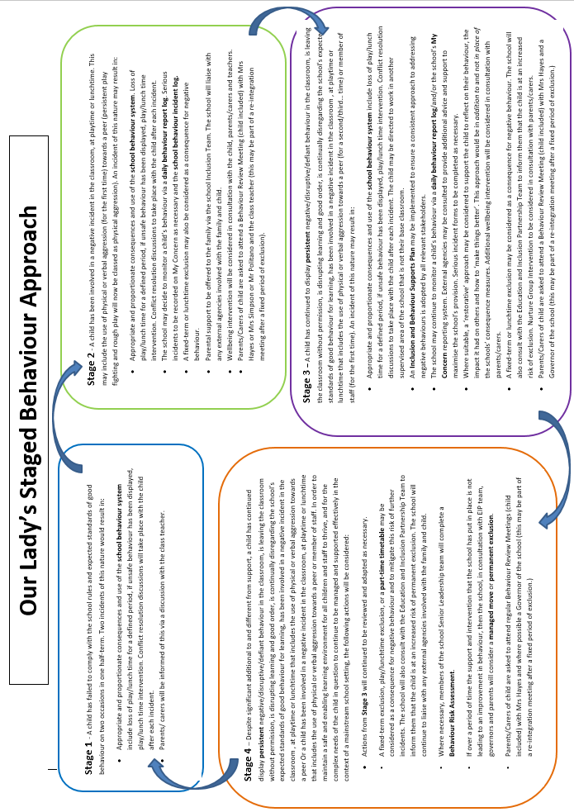
Appendix Four Behaviour Reflection

‘Ready, Respectful, Safe’
We want our pupils to feel proud to belong to their classroom, school and community. At Our Lady’s, we expect our pupils to:

Be READY to learn. This means:
- We arrive at school on time and with our equipment
- We come to school to learn and fulfil our potential
- We show that we are listening and try our best.

Be RESPECTFUL. This means:
- We treat others how we would like to be treated
- We listen when others speak
- We take care of our school environment and all of its possessions
- We welcome and celebrate what makes us different

Be SAFE. This means:
- We are responsible for our behaviour
- We move around school in a safe and calm manner
- We follow instructions to keep ourselves and other safe
- We use equipment safely and we stay safe online.

Which area/s do you think require reflection and improvement?

What mistake did I make?
What was the consequence of my mistake for me and for others?
What improvement/choice will I make in the future?

Date:

Appendix 5 Stage 1 Behaviour System
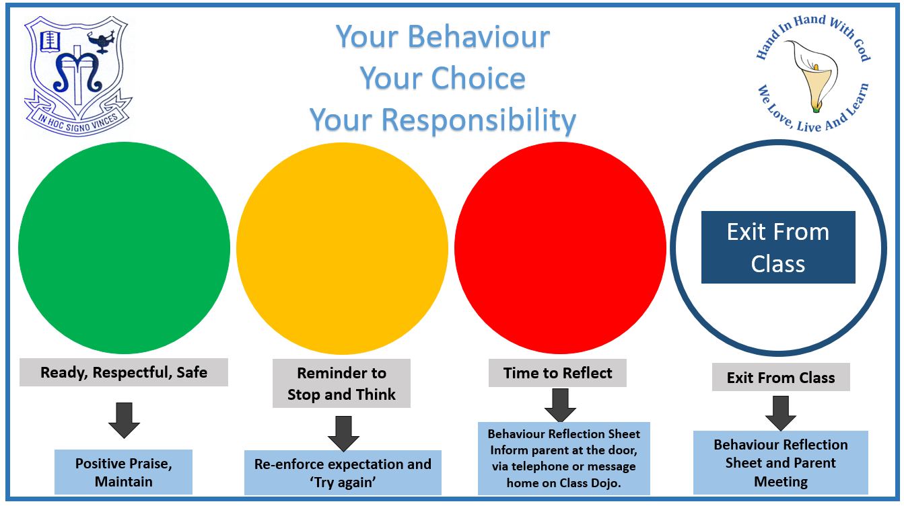

Appendix 6 Tier 1,2,3 Behaviour List

Tier 1:
- Ready
- Respectful
- Safe

Tier 2:
- Disruptive Behaviour
- Defiance and Refusal to Follow Instructions
- Dysregulation
- Damage - Equipment
- Inappropriate Language Use
- Refusal/Attempt to Complete Work
- Misuse of School Property
- Negative Comments Towards Others
- Play-fighting
- Play-fighting
- Persistent Off-Task Behaviour
- Spitting
- Swearing
- Unsafe Behaviour
- Uniform / Jewellery / Hair Infraction

Tier 3:
- Attempting to Flee
- Bullying Allegation
- Cyber Bullying
- Intimidation
- Bullying
- Pupil-on-Pupil Emotional
- Pupil-on-Pupil Physical
- Pupil-on-Pupil Sexual
- Pupil-on-Pupil Threat/Intimidation
- Disability Incident
- Damage - Property
- Fighting
- Homophobic Remarks
- Homophobic and Sexual Orientation Incident
- Inappropriate Mobile Phone Usage
- Leaving School Without Permission
- Physical Aggression - Adult
- Physical Aggression - Peer
- Possession of Dangerous Weapon / Implement
- Prejudicial Incident
- Persistent Lateness to School
- Peer on Peer Abuse
- Persistent Refusal/Disruptive Behaviour
- Racist Incident
- Religious Incident
- Sexualised Behaviour / Language
- Threatening Behaviour - Adult
- Threatening Behaviour - Peer
- Theft
- Violent / Adult Themed Language
- Verbal Abuse/Aggression - Peer
- Viewing /Sharing Sexual Content Via Social Media or Messaging
- Verbal Abuse/Aggression - Teacher

Appendix 7 Behaviour Incident Process Flow Chart
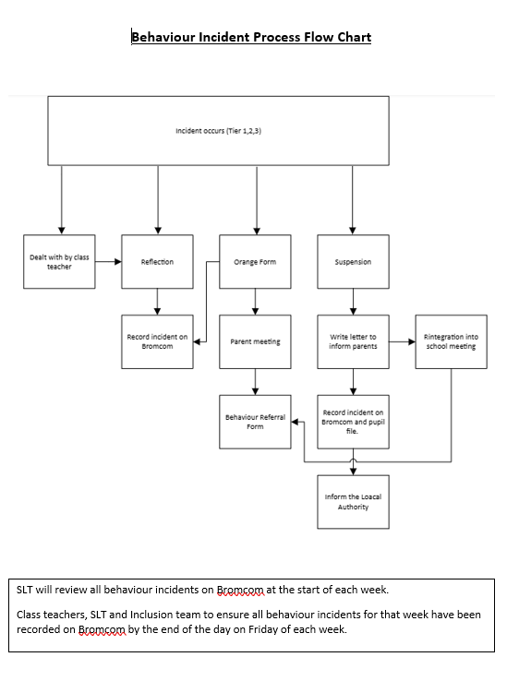

Appendix 8 Letter to Parent Initial Behaviour Incident

Dear Parent/Carer,

I am writing to inform you that your child has been involved a behaviour incident at school. This means that your child has not adhered to our key behaviour expectations of being 'Ready, Respectful and Safe'.

At Our Lady’s, we are committed to creating and maintaining an environment where exemplary behaviour is at the heart of effective learning. Everyone is expected to maintain the highest standards of personal conduct and to accept responsibility for their behaviour.

We believe it is important to address these issues promptly and collaboratively. We have spoken to your child and have encouraged them to reflect on their behaviour and have explicitly communicated how and why this needs to improve.

We request that you speak to your child at home to reinforce the importance of adhering to the expected standards of behaviour in school and emphasize why this is important for their personal, social and academic development.

Yours sincerely,

Maire Hayes
Head teacher

Appendix 9 Orange Incident Form Letter

Dear Parent/Carer,

I am writing to inform you that your child has been involved in persistent and/or serious behaviour incidents this term. This means that your child has repeatedly not adhered to our key behaviour expectations of being 'Ready, Respectful and Safe'.

We have previously communicated to you our concerns about your child’s conduct in school. Unfortunately, this has not led to a positive and sustained change in their behaviour and conduct

As a school we are steadfast and committed to creating and maintaining an environment where exemplary behaviour is the norm. The threshold of persistent and/or serious behaviour incidents which has been reached this term is a significant cause for concern.

We welcome the opportunity to share any underlying reasons or circumstances which could be contributing to this pattern of negative behaviour. But, it is important to be mindful that we expect all children who attend Our Lady’s to maintain the highest standards of personal conduct and to accept responsibility for their behaviour. This ensures that all pupils can thrive in an effective, safe and consistent learning environment

It is vital that prompt and decisive action is taken in partnership and agreement with home and school to prevent further behaviour incidents. As discussed, if behaviour does not improve, your child is at risk of the following escalatory measures in line with our Behaviour and Exclusion Policy. This may include:
- Lunchtime suspension
- Fixed-term suspension
- Not attending school events
- Not attending school trips
- Not attending after school clubs
- Not attending breakfast club
- Subject to a Daily Behaviour Report
- Behaviour support plan
Going forward, actions of support the home and school will implement in partnership will be monitored and reviewed and will hopefully support a positive change in your child’s attitude, behaviour and conduct.

Yours sincerely,

Maire Hayes
Head teacher

