How to activate your account:

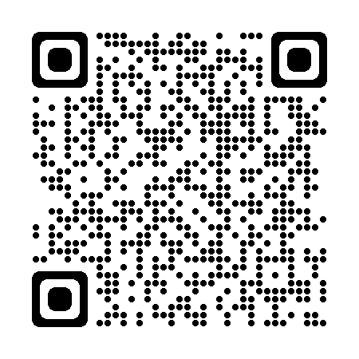 | 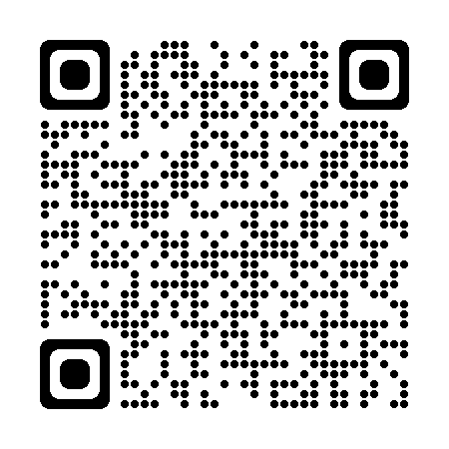 | 1: To begin you will need to download the MCAS app from either the Google Play Store if you are using an Android phone or the Apple App Store if you are using an iPhone.
Google Play Store | Apple App Store
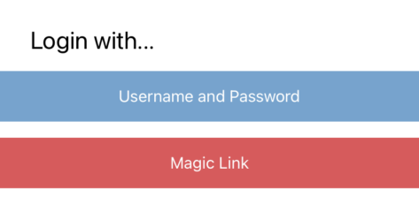 |  | 2: Once the App is opened, you can choose to log in with Username and Password or Magic Link.
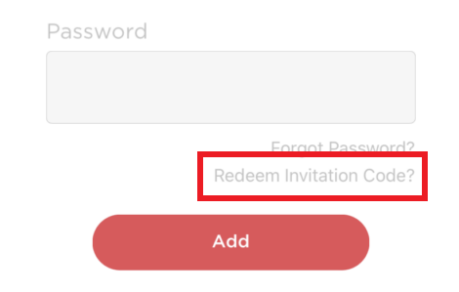 |  | 3: Pressing the Username and Password option will open the login screen.  At this point you MUST press Redeem Invitation Code at the bottom of the screen to activate your account.
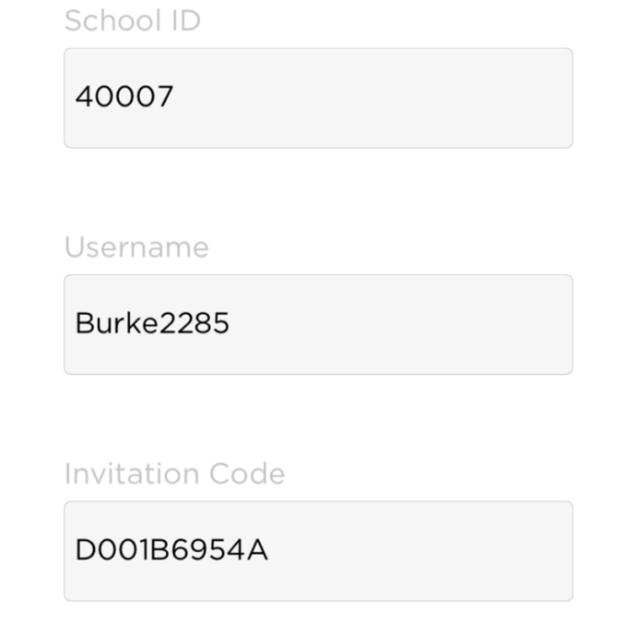 |  | 4: This will open the Redeem Invitation Code page. Fill in the school code (13097), your username and invitation code from the letter you were sent, then press Redeem Code.

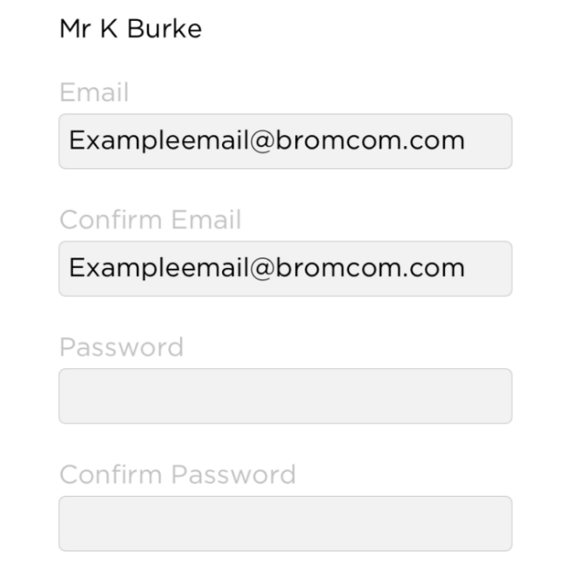 | 5: Once your code has been redeemed you will be asked to provide a valid email address and set a password.  The email address you use MUST be the one we have on record for you.  Your password must meet the following requirements:  - Minimum 8 characters  - At least 1 uppercase character  - At least 1 lowercase character  - At least 1 number  - At least 1 special character  Once all fields are completed press the Save Account Details button.
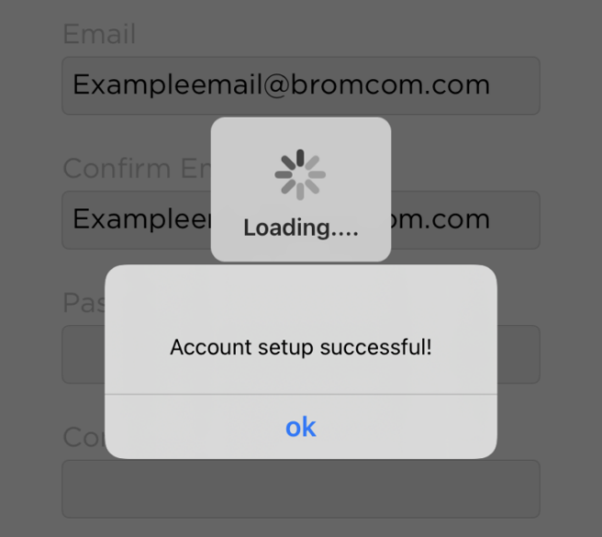 | 6: The app will now finish activating your account. You will receive a message once the account setup is complete.  Pressing OK will sign you into the MCAS app and you can begin to explore the portal.  You may be asked if you want to enable notifications. We recommend you do so as we may use these to send updates about school.

